Functional Specification (FS)
HENSAP Formula calculation
Prepared for: Calculating values for Component Thixotropic index.
Prepared by: Rajoy Rajan
Date: December 02, 2025
Overview
This Functional Specification (FS) describes the design and implementation of calculation for component Thixotropic index. This should not be an entry value .
Business Context & User Story
In the Test Schedule HENSAPFORMULA field and HENSAPORDERNUMBER are defined.
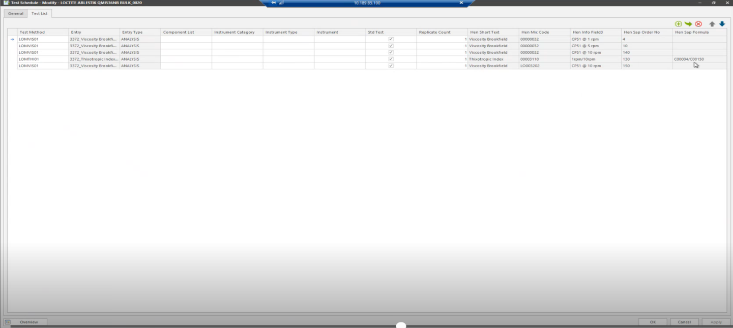

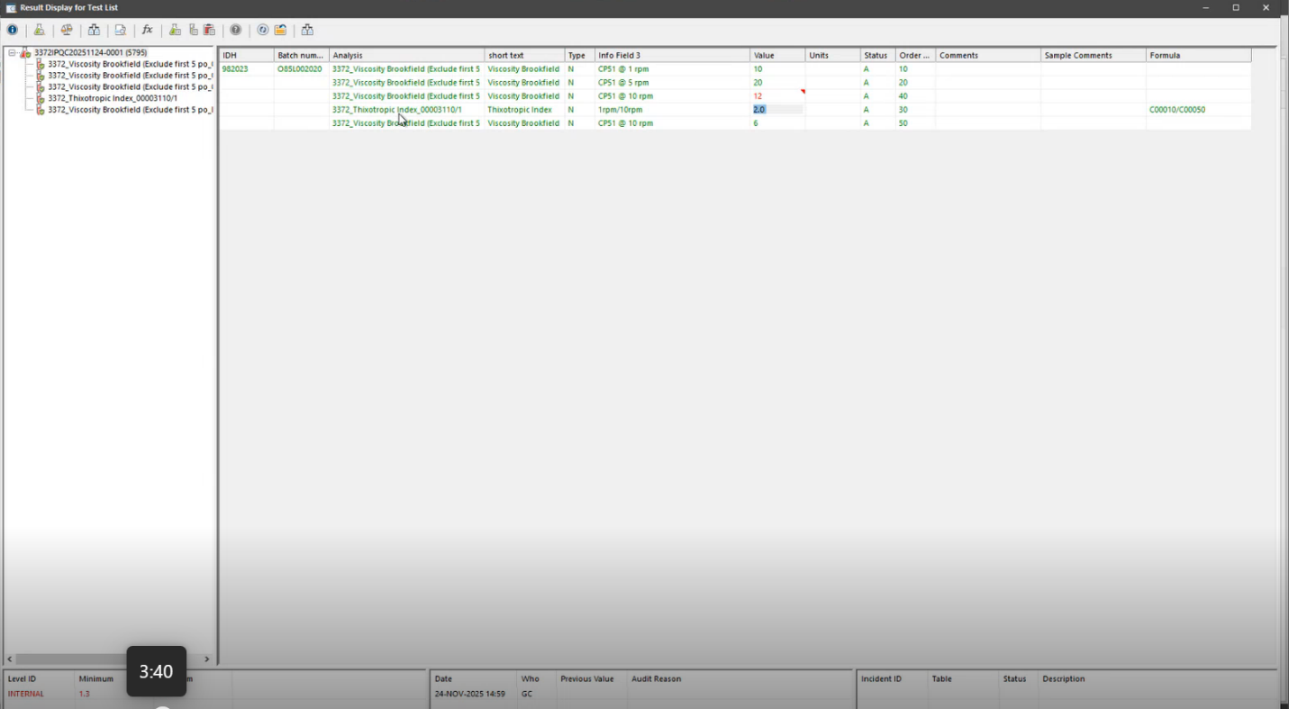
While the user enters the result ,Value for component Thixotropic index should be populated from a calculated formula from HENSAPFORMULA.

Functional Requirements
FR 1 : This Functional Specification (FS) describes the design and implementation of a calculation for component Thixotropic index .
The calculation will be available in the Test schedule against the analysis. For example, the formula will be C00010/C00050. The calculation will be 10 / 50, after trimming any character value.
This can be achieved by a new VGL calculation which Populates the calculated value.
Estimated Time for Development
2 days will be required to complete the VGL calculation.

